MALAWI SCHOOL CERTIFICATE OF EDUCATION

(FORM THREE)
HISTORY BOOKLET
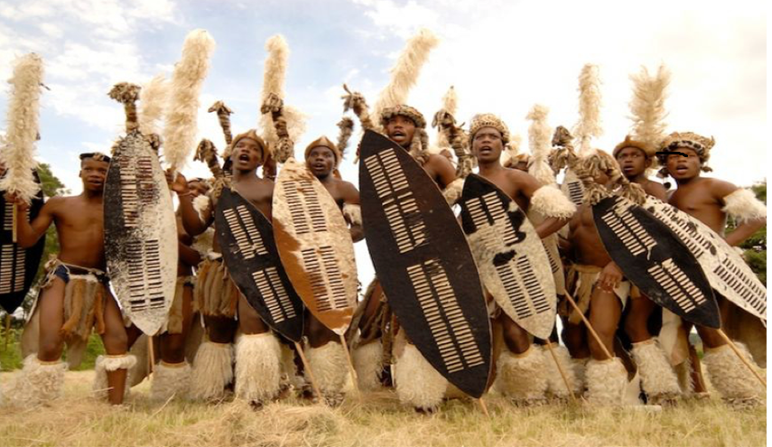
Compiled by
HARRY MATIMBA CHIDAONDA (0888676718)
(UNIVERSITY OF MALAWI -GRADUATE OF 2010)

